# CS 255 System Design Document Template

Roger Fisher 8/15/2025

This template lays out all the different sections that you need to complete for Project Two. Each section has guidance to prompt your thinking. You will need to continually reference the interview transcript as you work to make sure that you are addressing your client’s needs. There is no required length for the final document. Instead the goal is to complete each section based on what your client’s needs are. Remove this note when you are finished, and replace all bracketed text with the relevant information.

## UML Diagrams

### UML Use Case Diagram

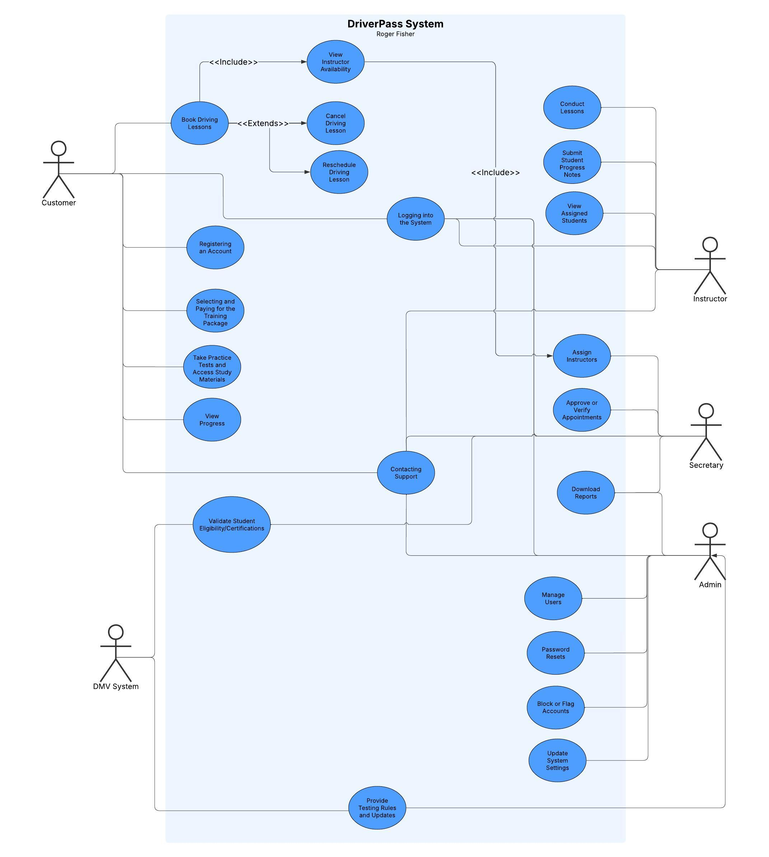

### UML Activity Diagrams

Taking Practice Test and Updating Progress

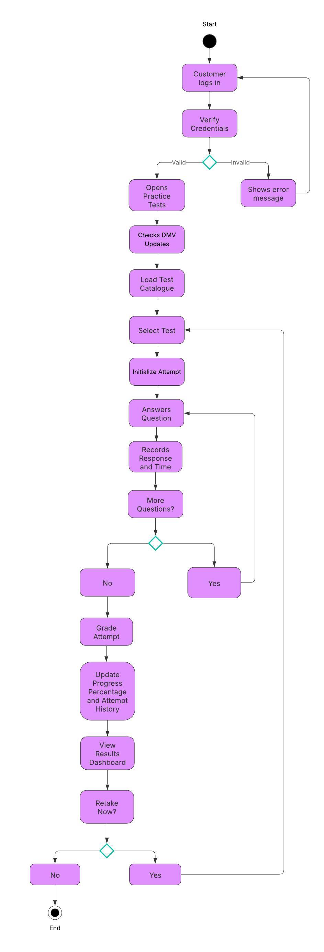

Scheduling and Modify Driving Lesson

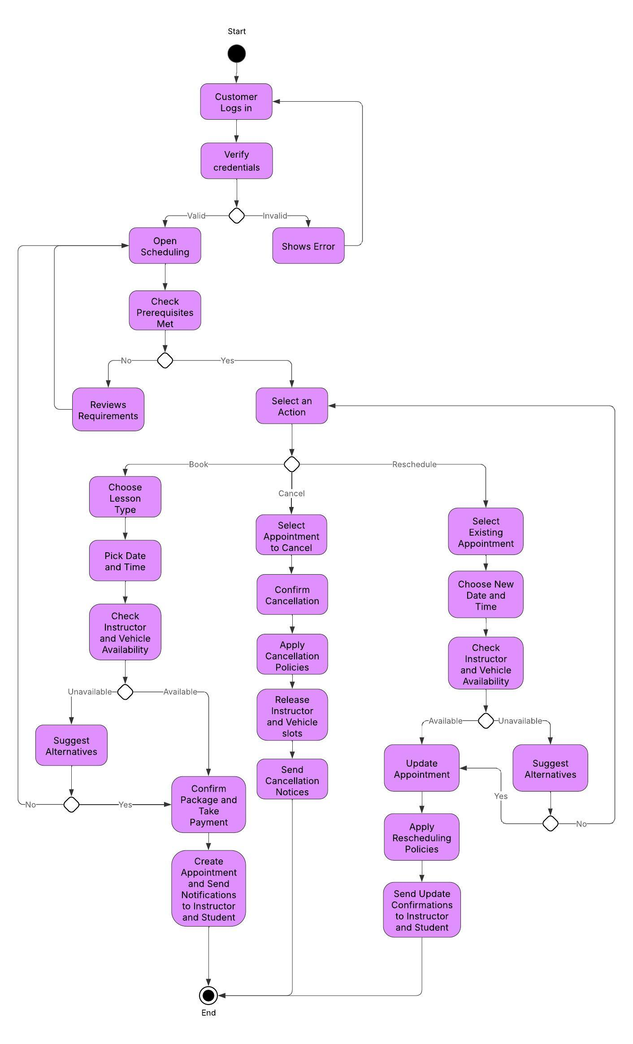

### UML Sequence Diagram

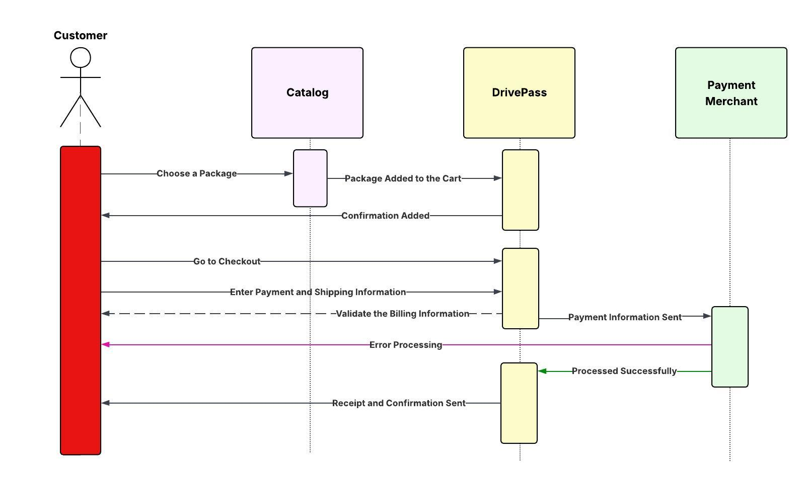

### UML Class Diagram

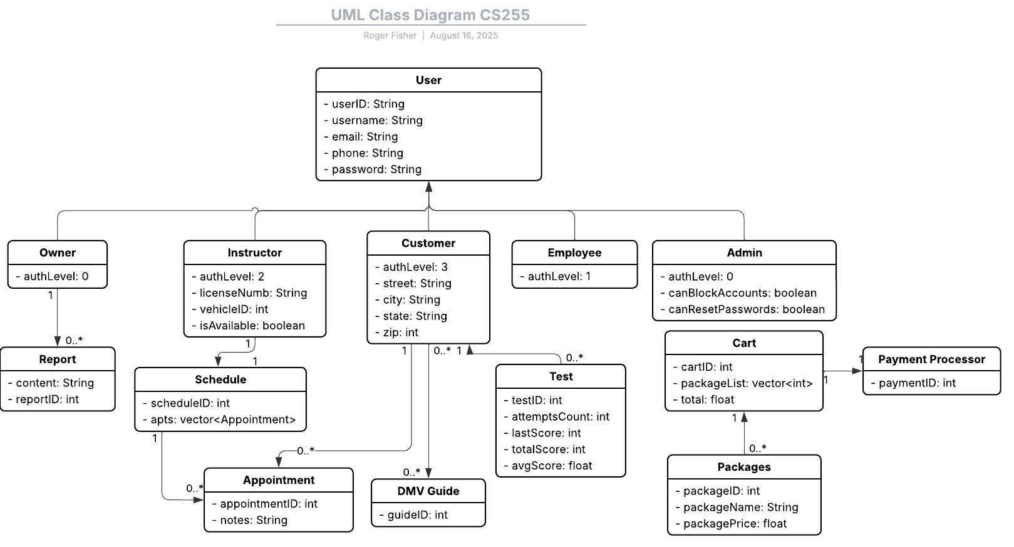

## Technical Requirements

The DriverPass system needs both front-end hardware and back-end hosting infrastructure to achieve high availability access to students, teachers, and administrators. Students will access the system through either laptops, desktops, or mobile devices with a modern browser to log in, make appointments and read study materials. Administrators and instructors will also have to have internet equipped devices with the same specifications, but administrative users can be required to have relatively more powerful machines to do reporting, data entry and management of the records. Since accessibility is a significant requirement, the system should support many devices, and the user would not need specialized hardware.

The application will have to be hosted on a secure and stable platform on the server side. The use of a multi-core processor, 8-16 GB of RAM, and scalable storage in the server will be adequate to deal with several users using the system simultaneously and storing data regarding scheduling, training and payments. In support of growth, the system can be hosted on a cloud-based server such as AWS or Microsoft Azure, which enables the business to scale up or down its resources as the use of the platform grows. It also needs to be frequently backed up, disaster recovery policies and frequent maintenance to make sure of high availability and low downtime.

When considered as a software solution, the DriverPass system may be constructed utilizing a web application framework, such as Java Spring Boot for the back end, and a relational database, such as MySQL or PostgreSQL to store user account data, training packages, schedules, and payment records. Front-end must be built based on standard web technologies (HTML, CSS and JavaScript) to guarantee browser and device compatibility. Other software needs involve banking connection through secure web server and supporting HTTPS connections, means of authentication protection of student and payment representations, and also integrations with external payment processing services.

The system will need to be created and maintained using an integrated development environment (IDE) like Eclipse or IntelliJ, a version control program to track changes like GitHub and an automated testing framework to test the quality of the code. Bug tracking and project management tools, like Jira or Trello, will also come to use in synchronizing the updates and system improvements. This tool and infrastructure choice allows addressing nonfunctional requirements such as system reliability, system security, and scalability.

Lastly, there needs to be powerful infrastructure policies to support the system. Among these are access of roles to segregate student, instructor, and administrator permissions, firewalls and network monitoring to guard sensitive data and frequent software updates to sustain system security. These will include industry standards and what the client has indicated as the primary concern about safety and trustworthiness; SSL certificates, encrypted data storage, and secure logins. The combination of these technical requirements leads to a system that is practical in use, feasible to develop, and scalable up to the business in the long run.